Subquery in SELECT: Show each student's total enrollments

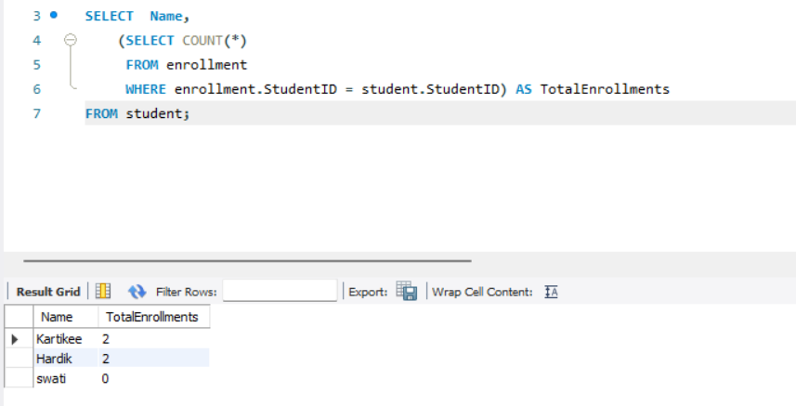

Subquery with IN: Students who are enrolled

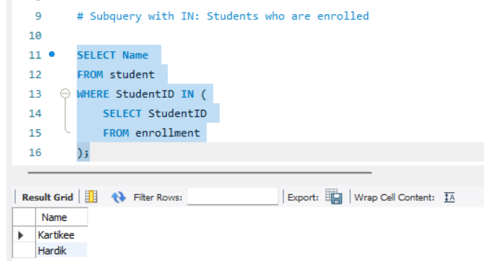

Subquery with EXISTS: Courses that have at least one enrolment

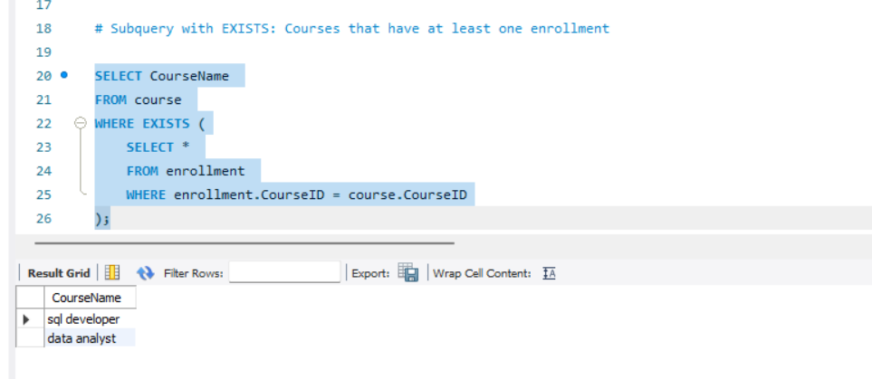

Correlated subquery in WHERE: Students with more than 1 course

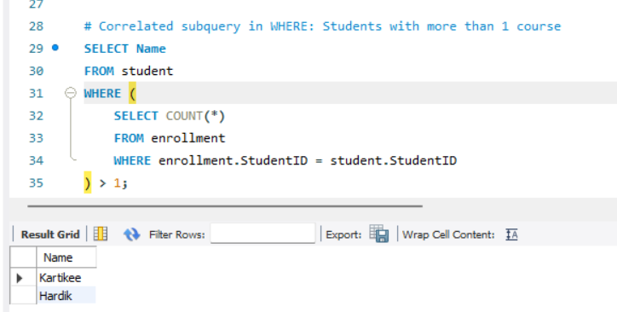

Subquery in FROM: Average number of courses per student

